# We are developing a website named “Goldsmith Jwellery Website”. The main objective behind this project is to develop a web oriented application which can provide shopping features to use the users. Through the system visitors are able to view different type of products available in the shop like different types of Jwellery which are suitable. User also able to pay payment for their purchase. In this project there are three different modules named admin, user and visitor. Admin manages all the modules. He adds different products to the system visitor view the website and do registration for the system. Now they become user and they are able to login the website through username and password. They can also view their previous order and also be able to cancel their current order. Users pay for their purchase and do online payment or cash on delivery, users also give their valuable feedback.

Now the customer can view and select Jwellery. Using this website customers also can able to order the Jwellery according to their needs. Customers do enquiry of Jwellery through this website about name, price and much more.

* **Goldsmith** Jwellery is an online store that enables website owners to sell their product online it is a web shopping application that enables the day to day sale functions.
* The system helps the customer to purchase the product with and without card information.
* It includes sophisticated product and customer management modules.
* This website will be useful to anyone who wants to purchase items using internet.
* Generates reports related to the system.

**Existing system:-**

* In the existing system all transactions, dealing of products, purchasing of products were done manually which is time consuming.
* Reports are prepared manually as and when needed. Maintaining of reports is very tedious task.
* To buy any product user has to collect information about it either by visiting the shop or asking people which is the better one.
* There is no computer system for handling payments. All calculations are performed manually which may not be accurate always. Maintaining the record is really a tedious task.
* Any internet user can use this existing website to search for any kind of products, select particular products from a wide range of products.
* Once they make of their mind to purchase any particular thing they can place an order and make a payment throw various available payment option.

**Proposed system:-**

* Online Shopping Portal is specific requirement of the client that integrates the buying and selling services especially to their customers.
* Need for the new system is due to major drawbacks of existing system.
* Reports can be generated at any time within few seconds, so that manual labor is not required, and also analysis can be performed much more frequently which helps in taking decisions.
* The details regarding all users, products can also be maintained as their information is very helpful and sometimes becomes a critical requirement.
* Allows user to get registered from their places and transact for the required product.
* To overcome these problems in existing system we develop **“Online Shopping Portal”**.

**Front End:-**

**Introduction to ASP.NET with C**#

ASP.NET is a development environment which runs under Microsoft Visual Studio 2010. ASP.NET is “Event Driven” because all activities in a program are triggered by one event or another. ASP.NET is also called as “Object based language” because it moves around object/control. Development process in ASP.NET is very fast as compare to Traditional Procedure Oriented Programming. So, ASP.NET is very useful environment for develop web Applications. The basis of this development platform, it consist of two primary components –

1. Common Language Runtime –

It is the environment where all programs in .NET are run. It provides various services like memory mgmt & thread mgmt. Programs that run in the CLR need not manage memory, as it is completely taken care by the CLR.

1. The .NET Framework Base class –

Software developer uses a personalized set of tools in terms of classes & components. The .NET class library provides a common interface between all the different .NET programming languages.

**Microsoft Visual Studio Editions**

It has Two Editions-

**Microsoft Visual Studio 2010**

**-** .NET framework 3.5

- .NET framework 4.0

- .NET framework 4.5

**Microsoft Visual Studio 2013**

**-** .NET framework 4.5

**Features of .NET:-**

* **Interoperability:-**

Because computer systems commonly require interaction between new and older applications, the .NET Framework provides means to access functionality that is implemented in programs that execute outside the .NET environment.

* **Common Language Runtime Engine:-**

The [Common Language Runtime](http://en.wikipedia.org/wiki/Common_Language_Runtime) (CLR) is the execution engine of the .NET Framework. All .NET programs execute under the supervision of the CLR.

* **Language Independence:-**

The .NET Framework introduces a [Common Type System](http://en.wikipedia.org/wiki/Common_Type_System), or CTS. Because of the CTS feature, the .NET Framework supports the exchange of types and object instances between libraries and applications written using any conforming [.NET language](http://en.wikipedia.org/wiki/List_of_CLI_languages).

* **Base Class Library:-**

The [Base Class Library](http://en.wikipedia.org/wiki/Base_Class_Library) (BCL), part of the Framework Class Library (FCL), is a library of functionality available to all languages using the .NET Framework. The BCL provides [classes](http://en.wikipedia.org/wiki/Class_(computer_science)) which encapsulate a number of common functions.

* **Simplified Deployment:-**

The .NET Framework includes design features and tools that help manage the [installation](http://en.wikipedia.org/wiki/Installation_(computer_programs)) of computer software to ensure that it does not interfere with previously installed software, and that it conforms to security requirements.

* **Security:-**

The design is meant to address some of the vulnerabilities, such as [buffer overflows](http://en.wikipedia.org/wiki/Buffer_overflow), that have been exploited by malicious software. Additionally, .NET provides a common security model for all applications.

**Back End:-**

**Introduction to Microsoft Access:-**

Using MS-Access we can manage all information within single database file. Within the file, we can divide data in separate storage container called table.

**Features of access:-**

* Working on the internet or intranet.
* Working on other applications.
* Working with sample applications.
* Working in the database window.
* Using and customizing toolbars, menu bars and shortcut menus.
* Working with data.
* Working with filters.
* Printing and previewing.
* Designing a database.
* Creating and customizing tables.
* Creating and customizing query.
* Creating and customizing forms and reports.
* Working in the module window, debug window and object browser.
* Programming with visual basic.
* Securing and administering a database.

**Fact Finding Techniques (methods):-**

Gathering facts is not virtual, it should be done with diligence .

Information gathering and complex organization is not an easy task.

It has to be in an organized way .

1. No system details are left out.
2. Right problems are identified and repetitive problems are avoided.
3. Wrong or incomplete details are not collected.

Fact finding techniques that are commonly used,

They are

* **Existing system document review**:-

Record and Document Searching .

* **Interviewing:-**

The method is used to collect the information. It gives quantitative information about problems. Failures, objectives, constraints.

* **Record Viewing:-**

This method is used to establish the information. It includes different types of files maintained for everyday collection of information.

**Project Planning:-**

We were suggested by our guide to choose a shop which can be actually observed and studied closely. We decided to choose “GoldSmith Jwellery”

So we can observe the different types of Jwellery that can purchase various types of Jwellery. They were help us to design our website more efficiently and neatly.

We first classified all the products according to their categories. Then we referred to the similar e-commerce websites to get the ideas for designing so we could improve our work. We distributed equal work to each of our team member.

Site map

Logout

Cancel Order

My Order

My Profile

Home

User Login

Enquiry

Feedback

Shopping

Delivery

Gold Coin

Diamond

Platinum

Gold

Policies

Contact Us

Category

About

**GoldSmith Jwellery Home Page**

Admin

Manage product

Add model

Add product

Add Category

Home

Manage admin

Manage user

Manage order

Report

Logout

**ERD:-**

payment

pay

customer

do

product

give

order

place

feedback

manage

add

Admin

1

M

1

1

1

M

M

M

M

M

1

M

1

1

view

enquiry

M

Represent the information that should be kept in mind when making a decision and this diagram use we are calculate how many entities are included in the system.

Following are the different standard signs used in these diagrams and they are representing with its meaning.

* **Process:-**
* **Entity:-**
* **Database:-**

* **Flow of Data:**

**Context Level DFD:-**

Jwellery information

Admin

Customer

Mangement System

Customer Order

Order detail

**First Level DFD for Admin:-**

Login details

Admin_details

Login Response

Request for enquiry details

Login details

Enquiry details

Enquiry details

Request for custom

details

details

Enquiry details

Registration details

customer details

Admin

User details

request for

details

Order ­_details

Order details

Genrate the bill

Bill detail

Billing_details

Order for detils Get feedback

Feedback_deatails

Feedback Response

Feedback details

Response details feedback

**First Level DFD for Customer:-**

View Jwellery information

Login details

Resitration_details

Login response

Login details

Select Jwellery

Customer

Jwellery details

Order details

Give order details

Order _details

Give feedback

Feedback details

Feedback detail

Give enquiry

enquiry_details

**Use Case Diagram:-**

Admin

Customer

**Solution Explorer:-**

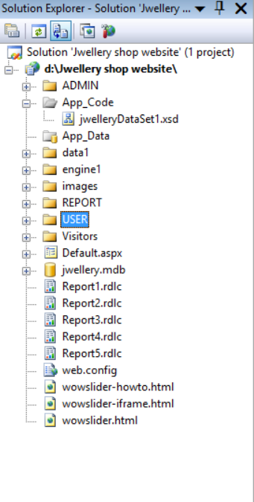

**Database:-**

**Table name:- Feedback detail**

**Design View:-**

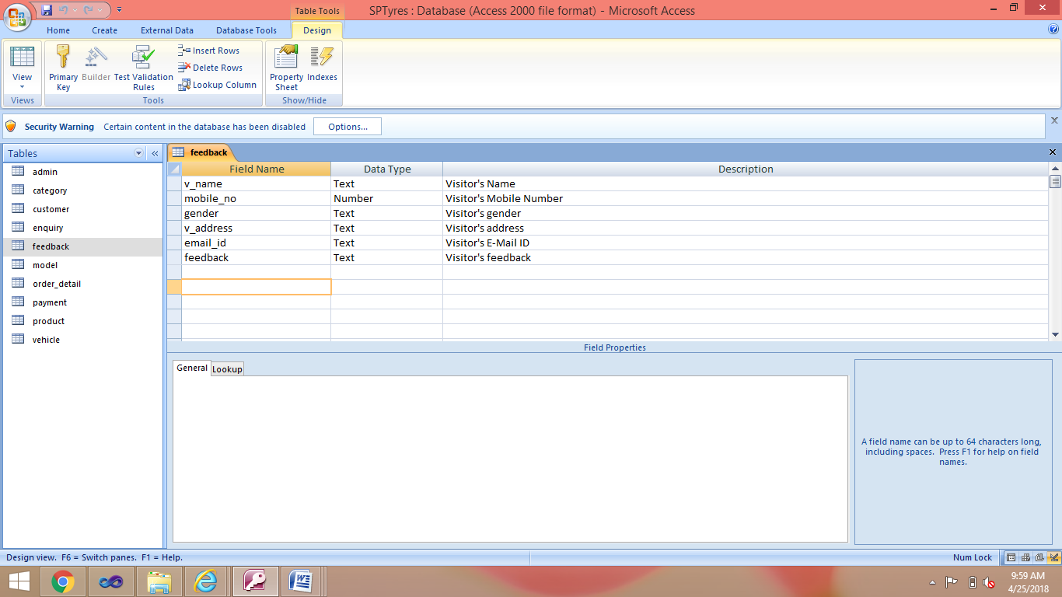

**Table View:-**

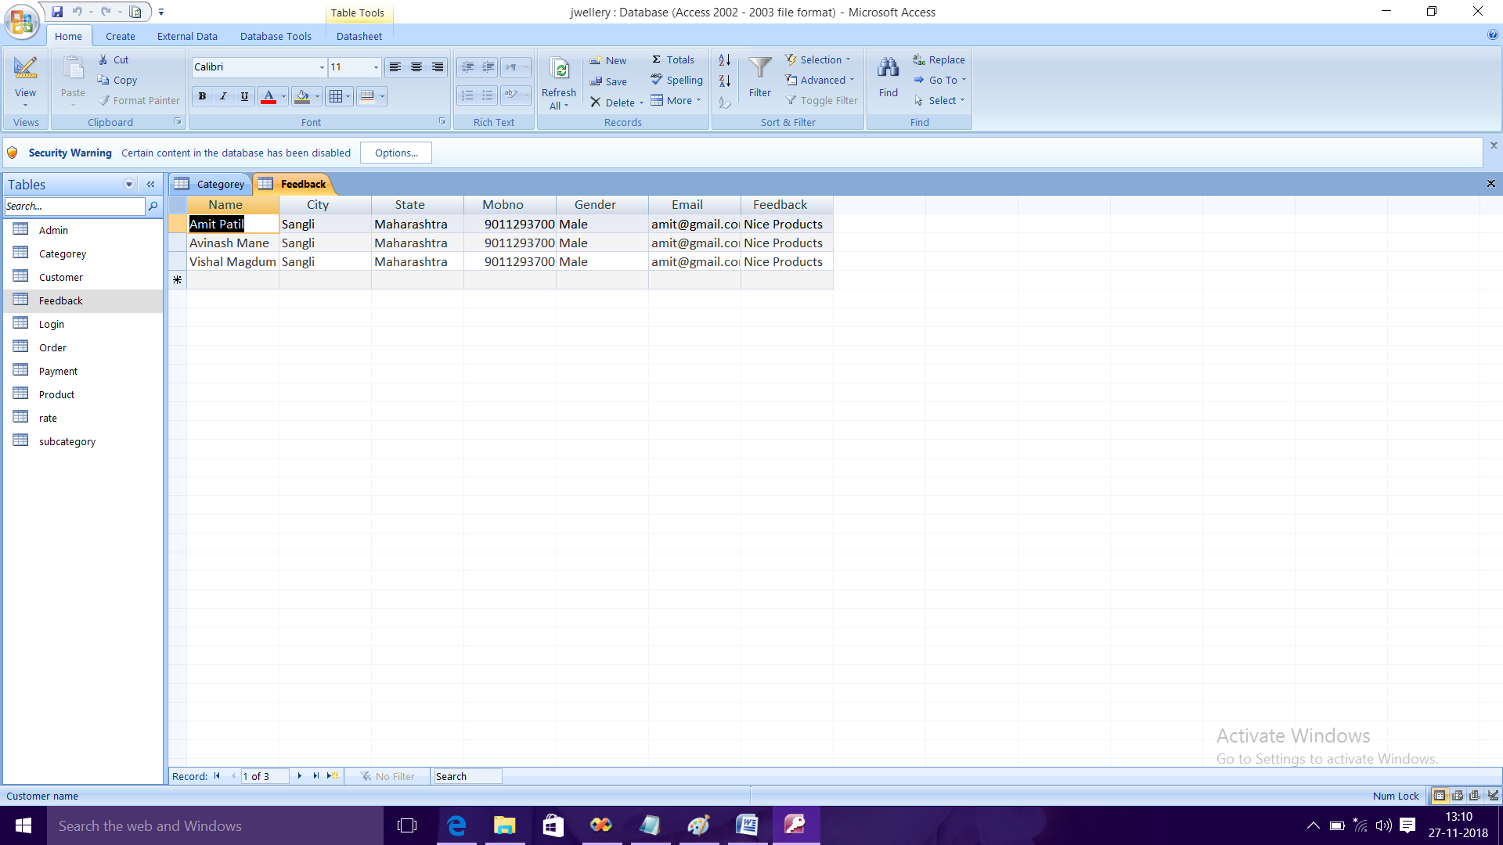

**Table Name:- Login**

**Design View:-**

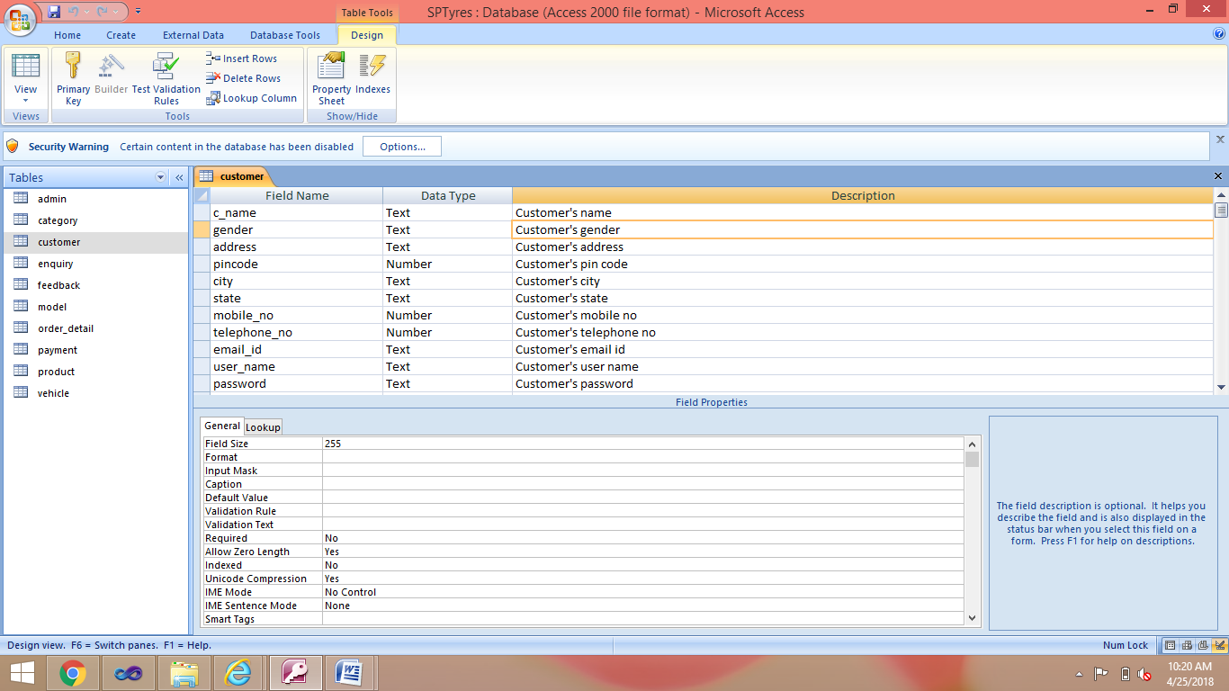

**Table View:-**

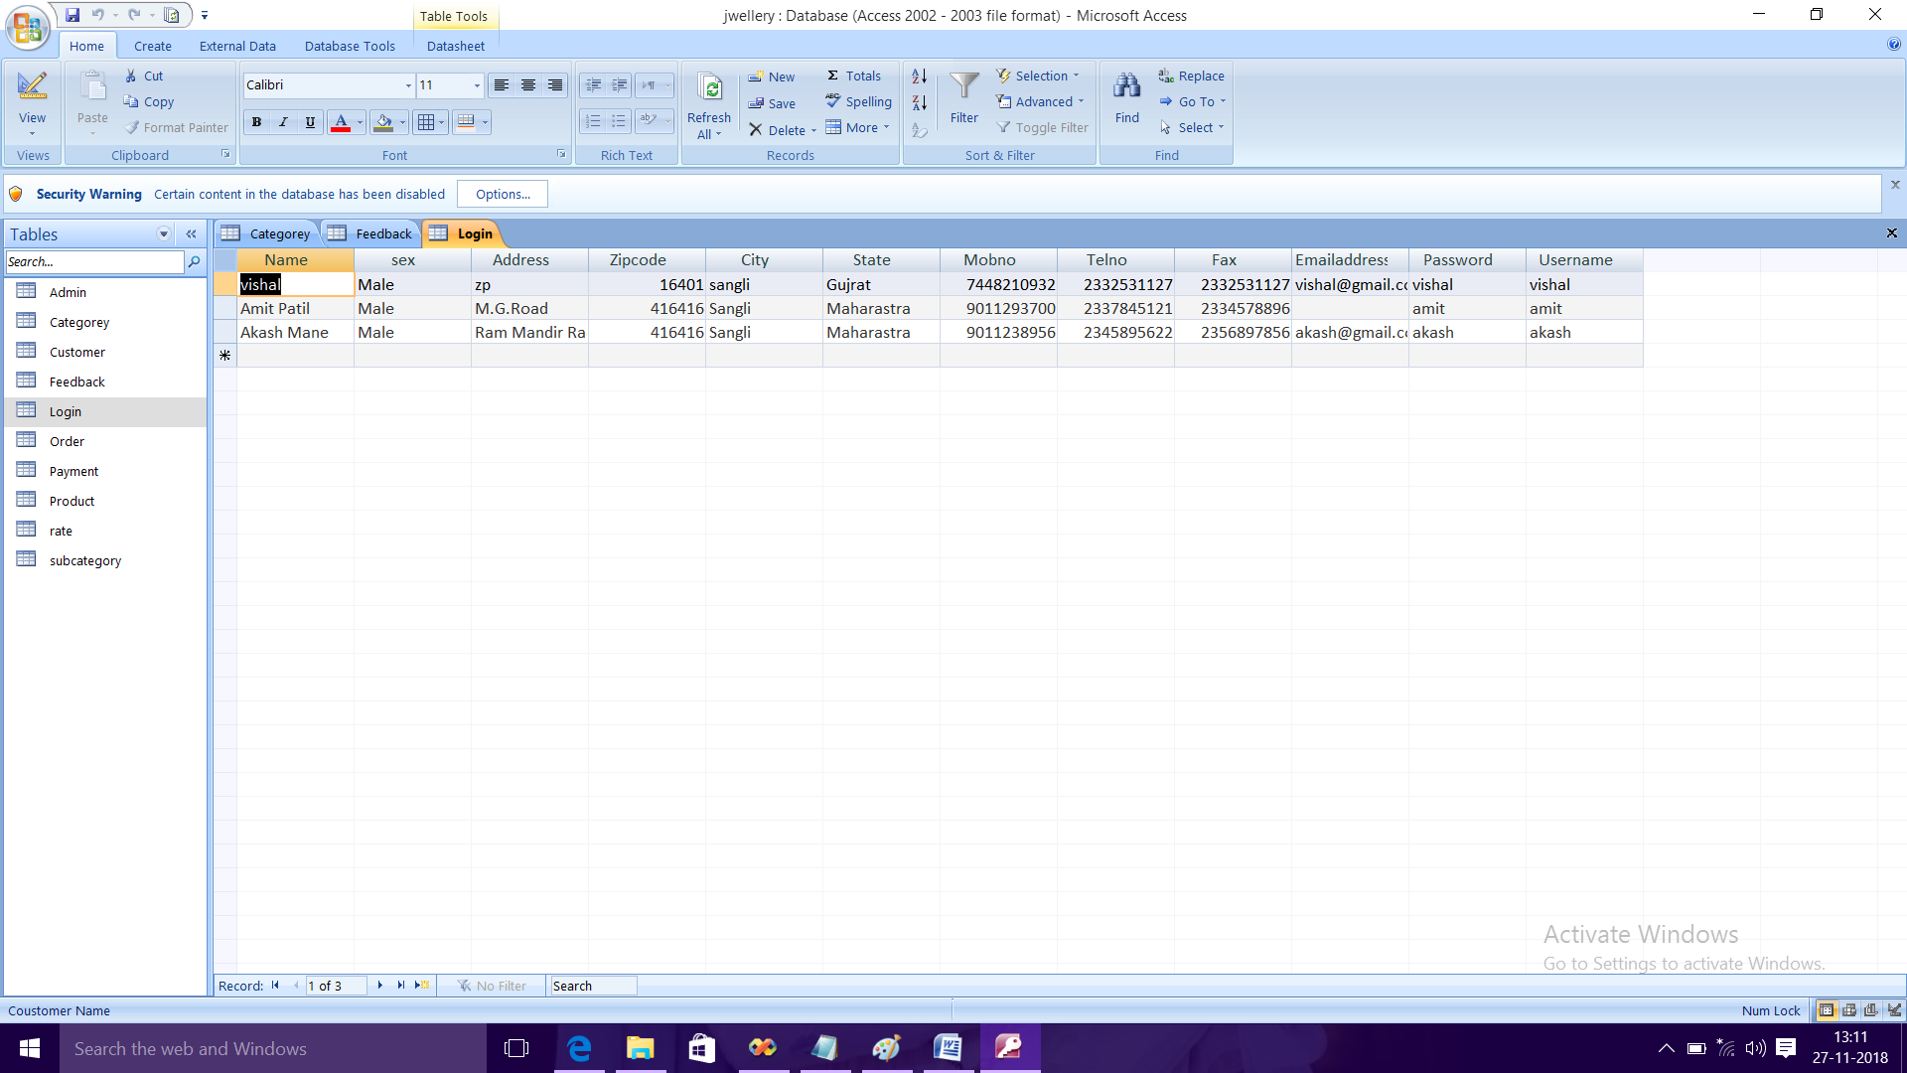

**Table name:- Order**

**Design View:-**

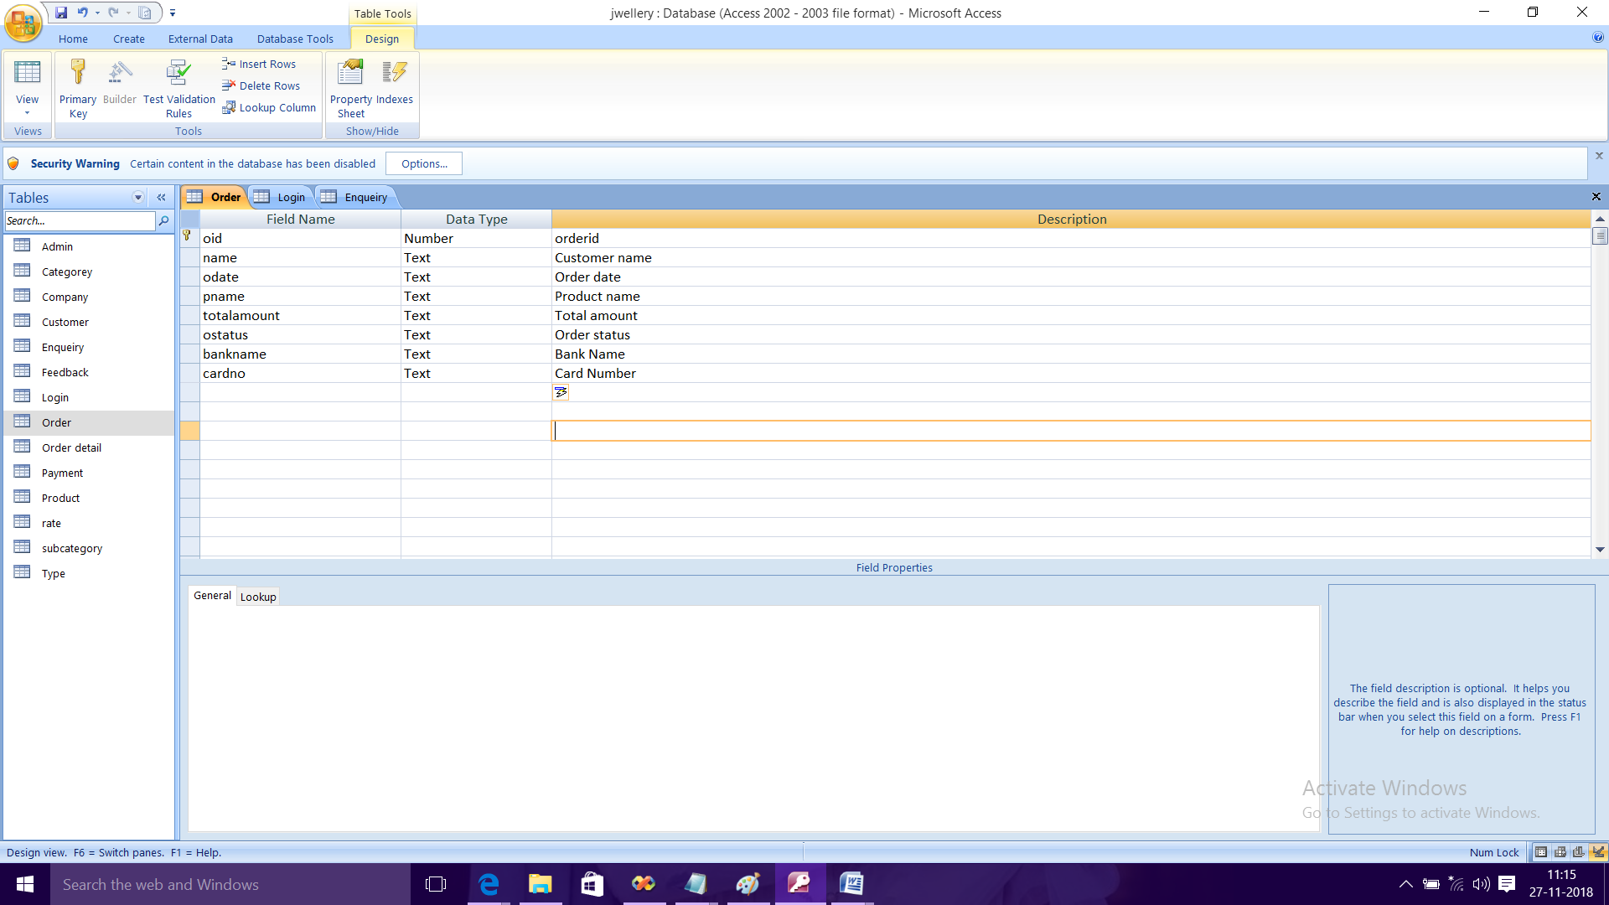

**Table View:-**

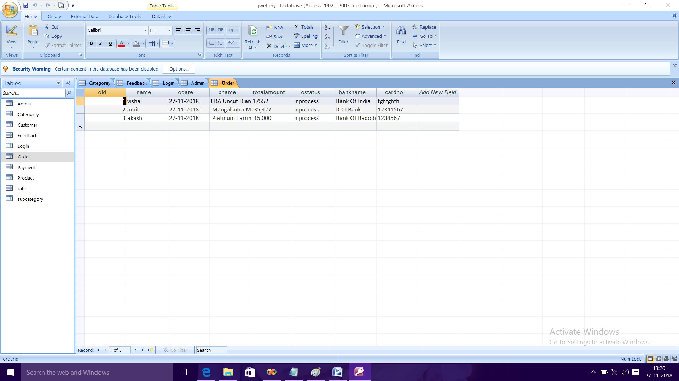

**Table name:- category**

**Design View:-**

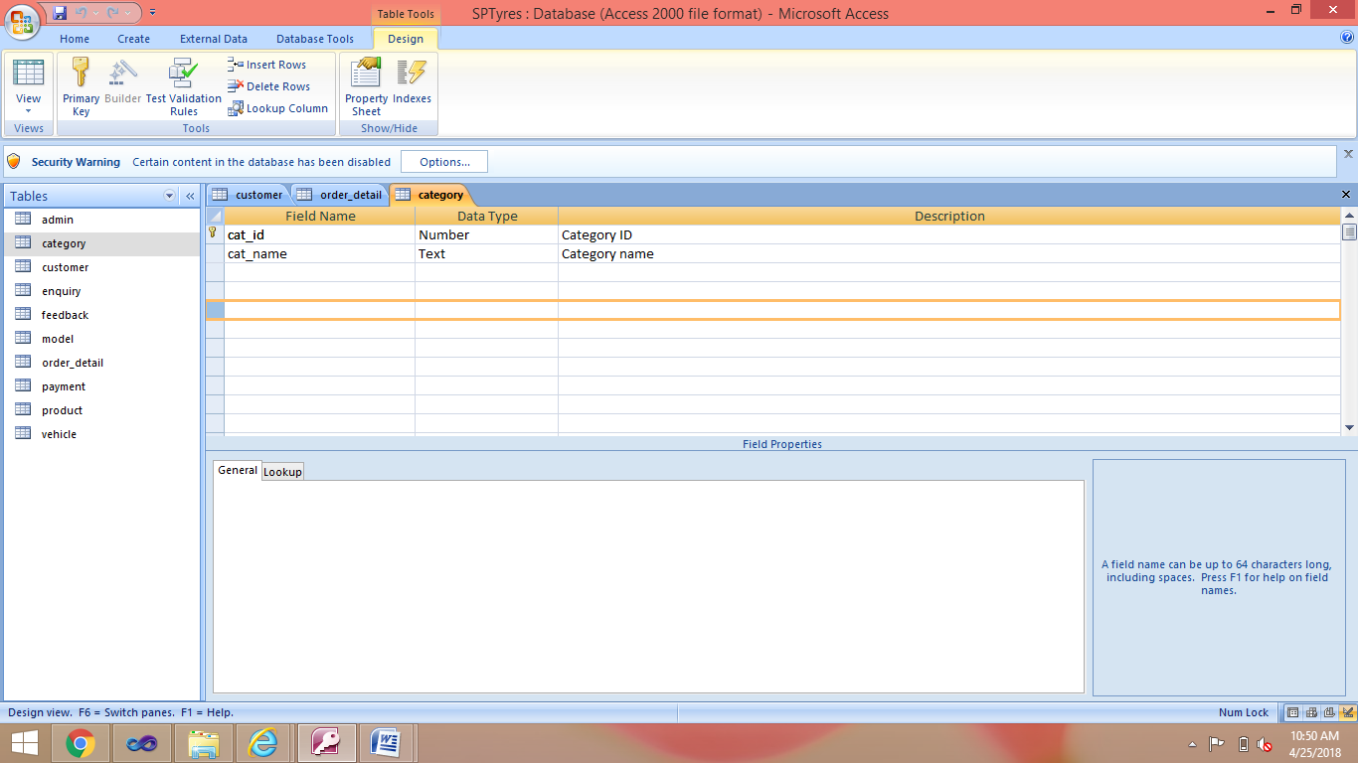

**Table View:-**

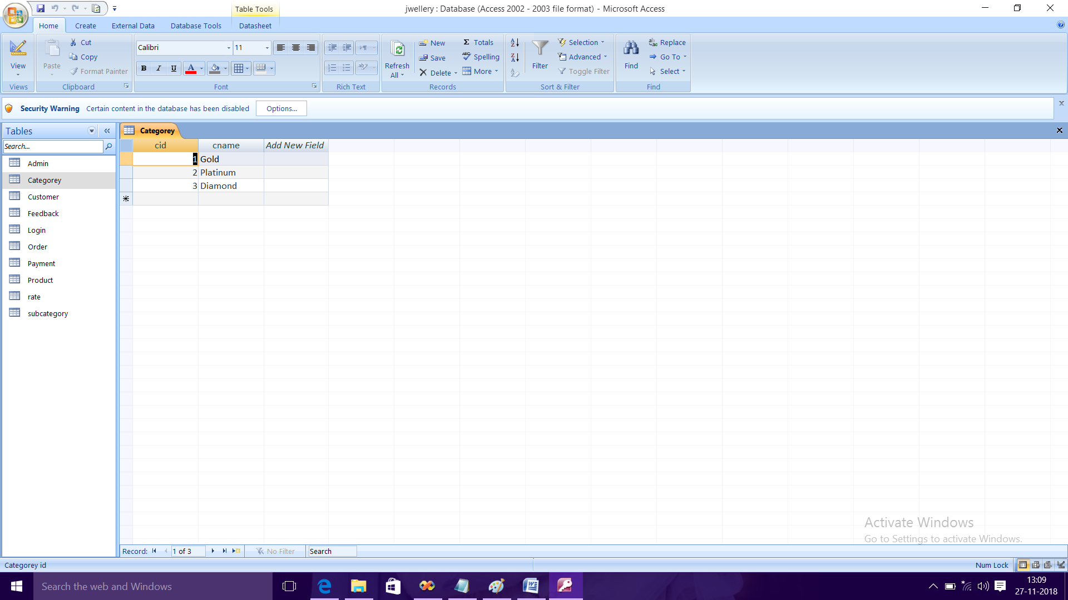

**Table name:- admin**

**Design View:-**

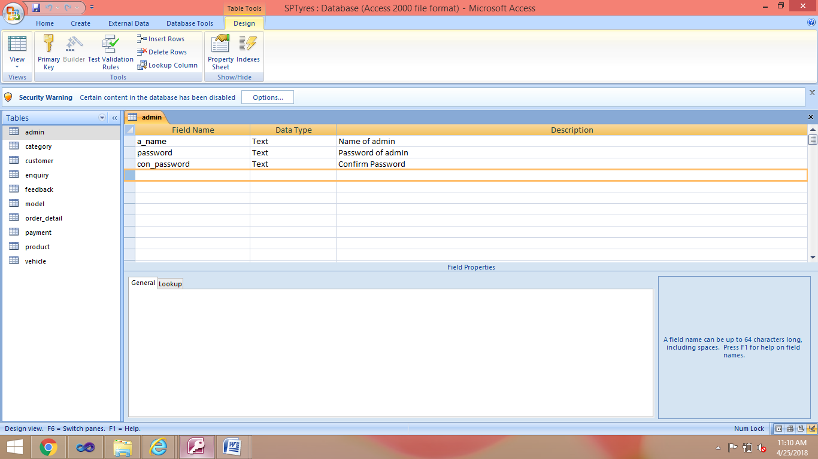

**Table name:- subcategory**

**Design View:-**

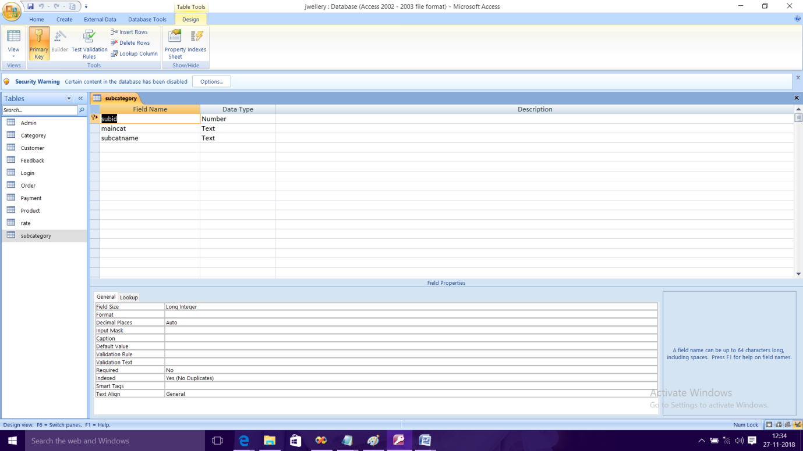

**Table View:-**

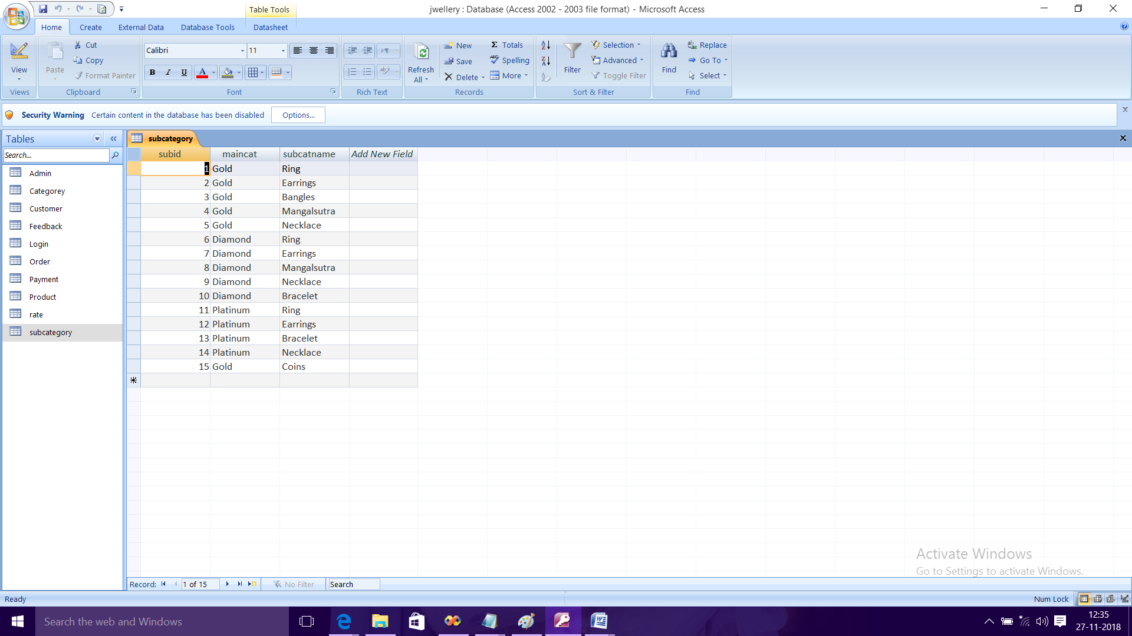

**Table name:- rate**

**Design View:-**

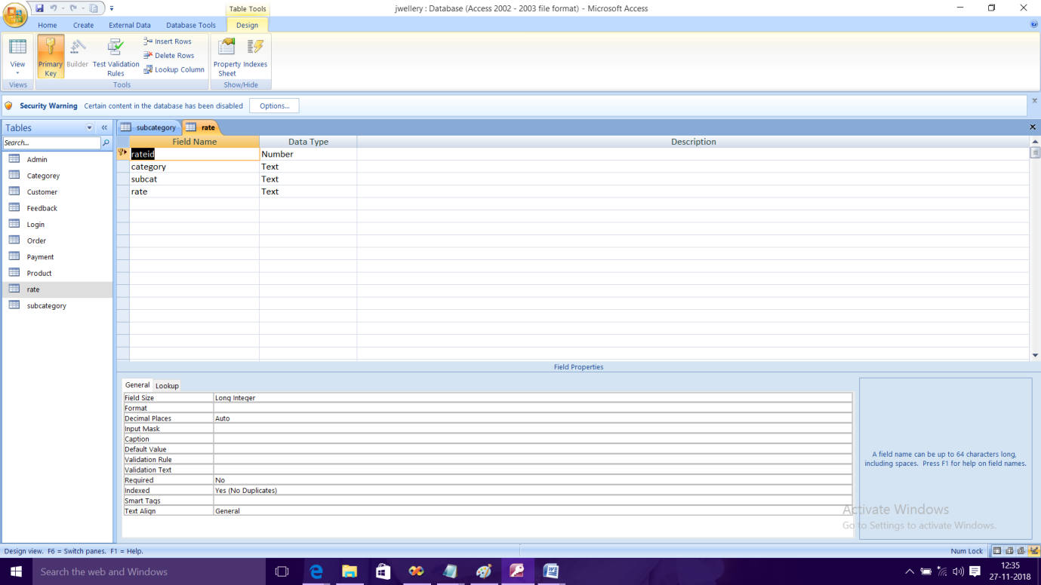

**Table View:-**

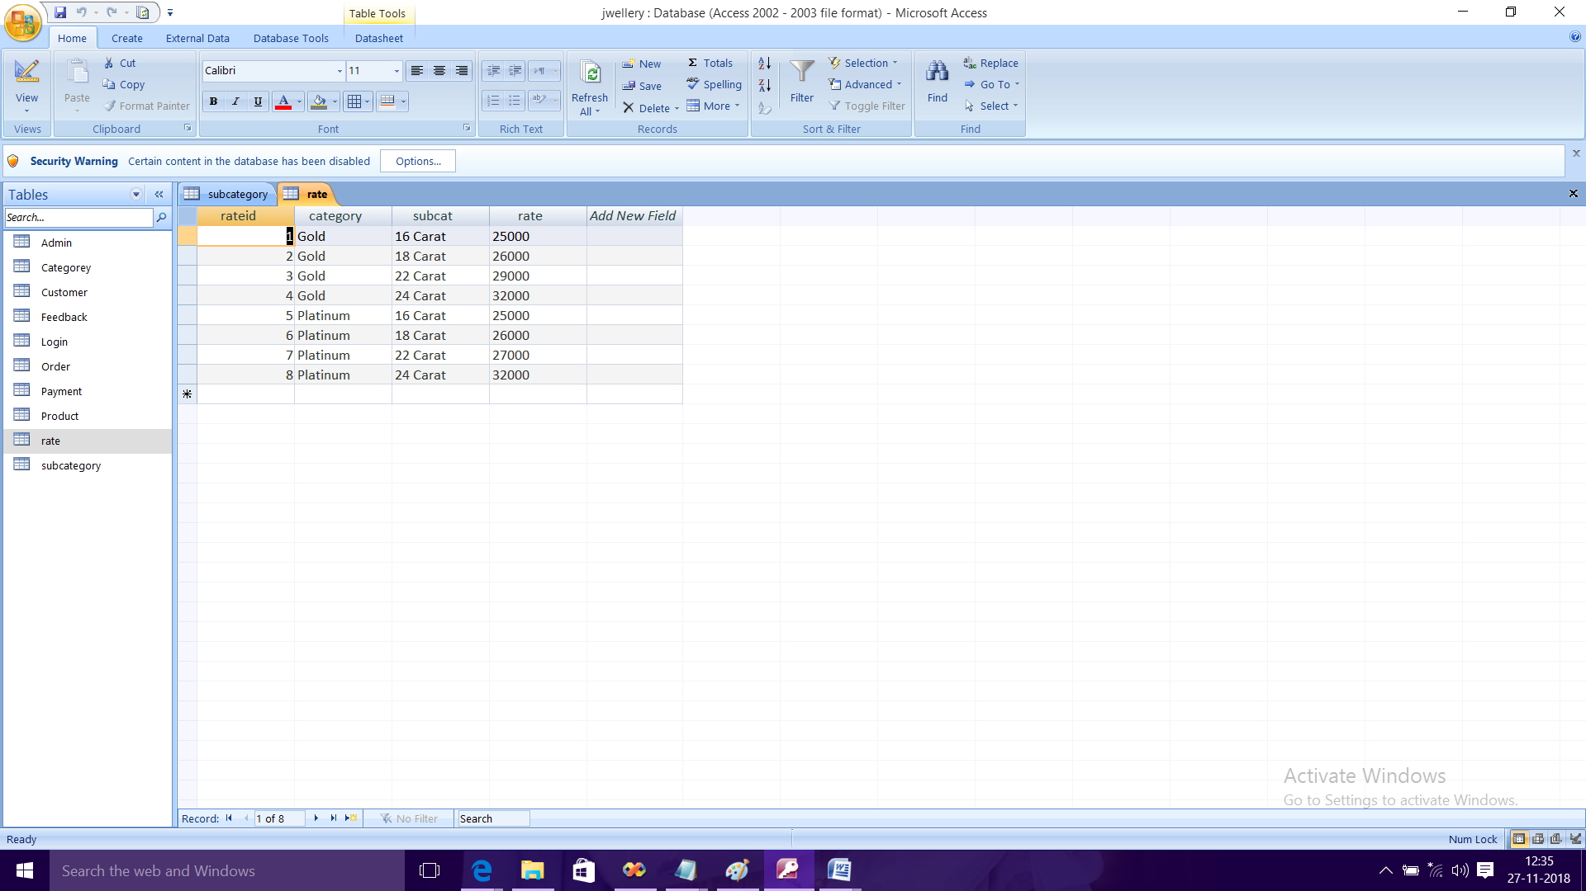

**Table name:- product**

**Design View:-**

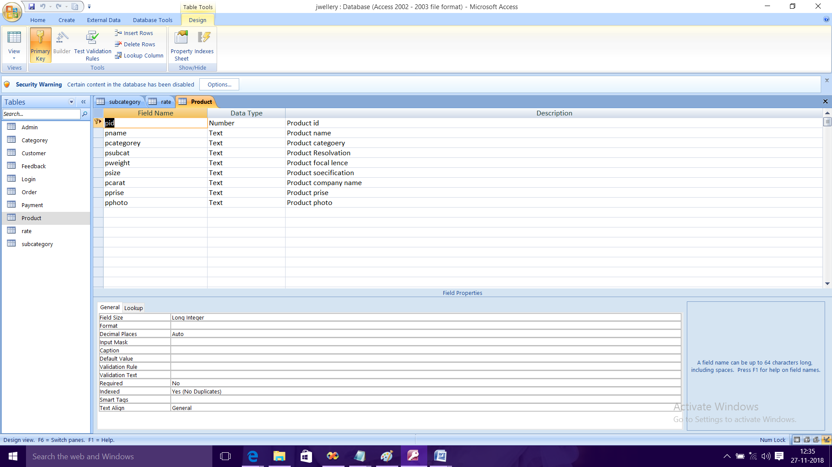

**Table View:-**

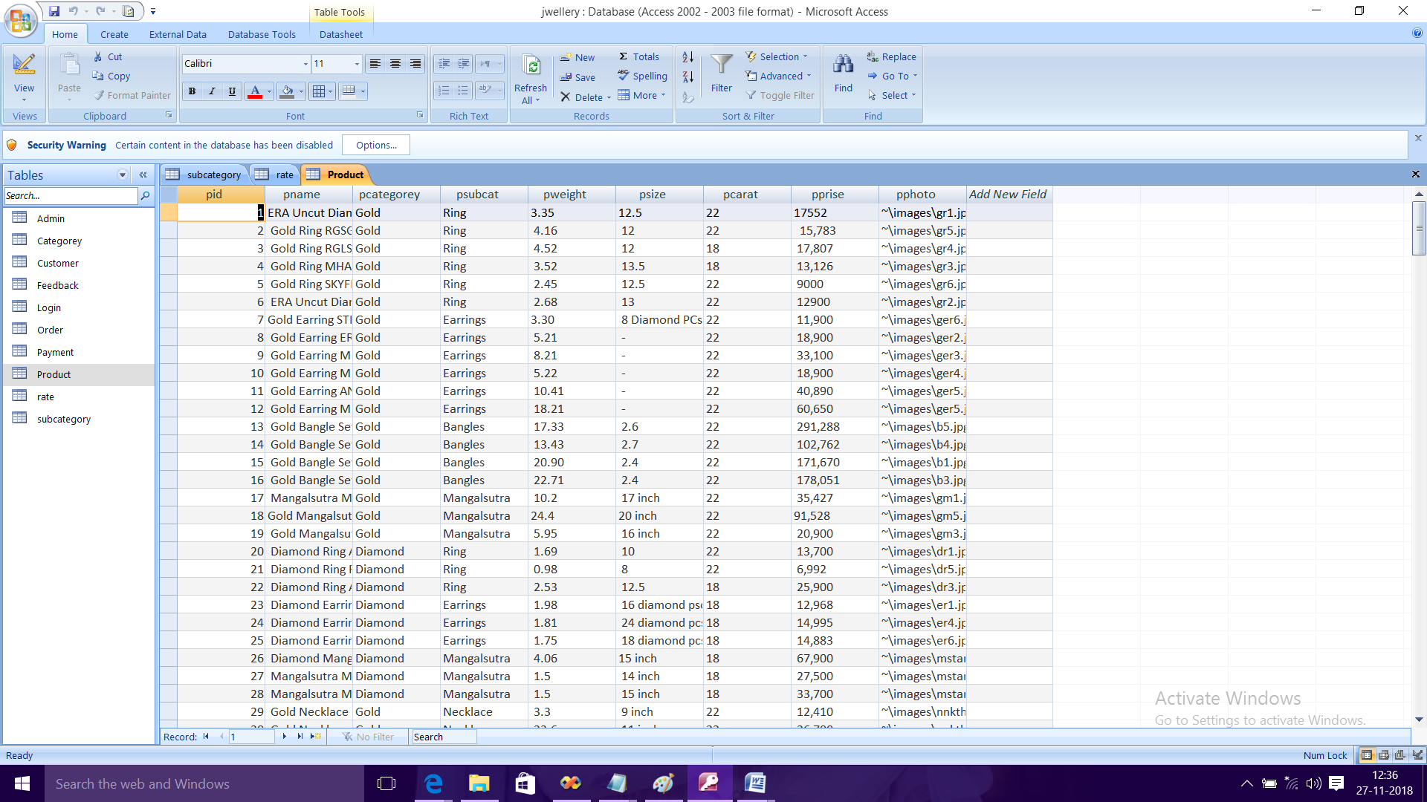

**Home Page:-**

**Home page of the website.**

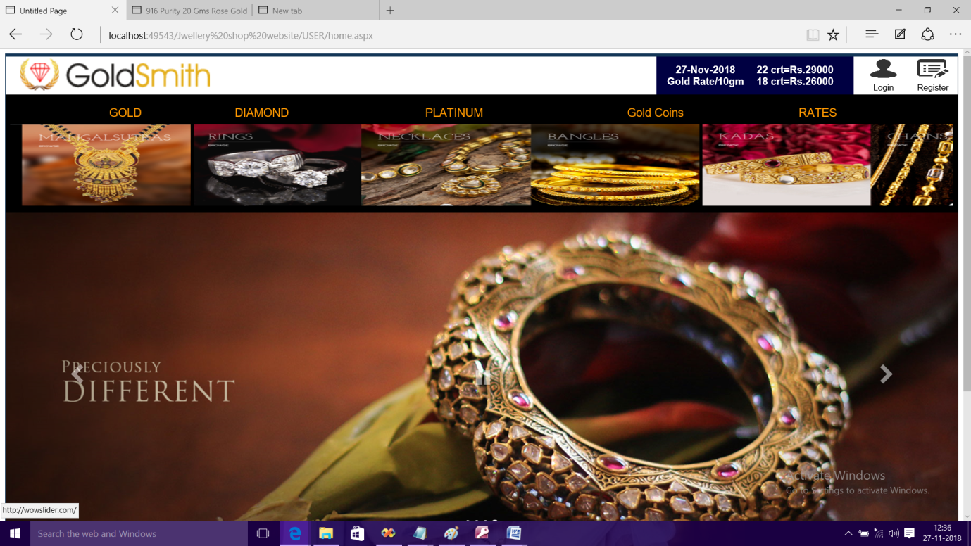

**About Us:-**

This page shows about us of GoldSmith Jwellery.

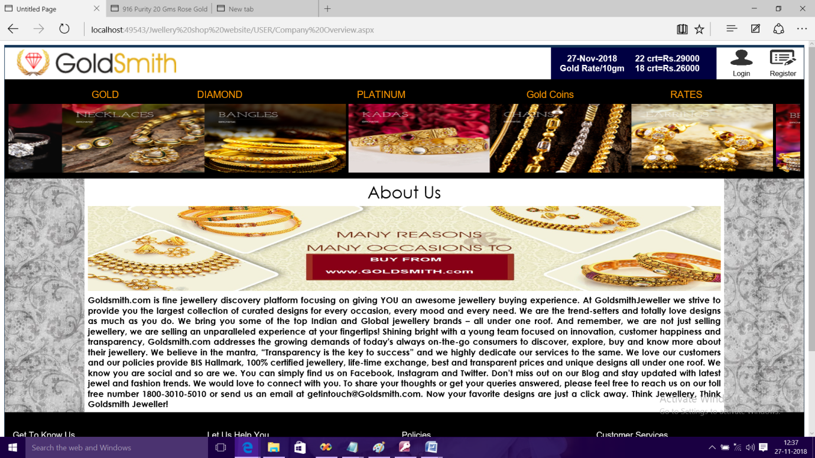

**Contact Us:-**

This page shows contact us of GoldSmith Jwellery.

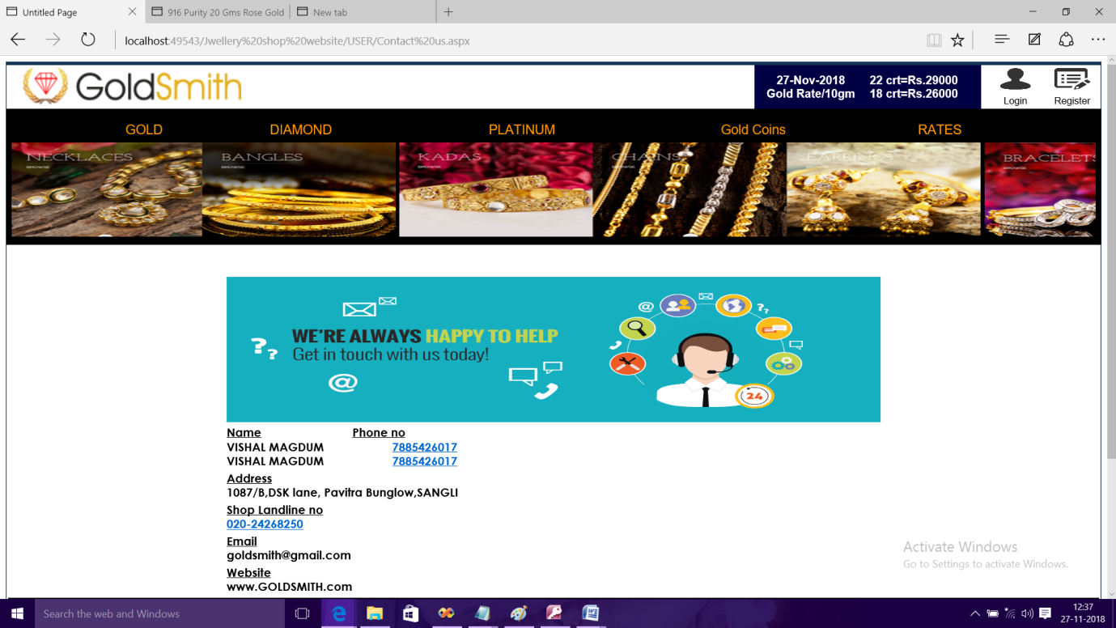

**Polies:-**

This page shows Shipping Policy of GoldSmith Jwellery.

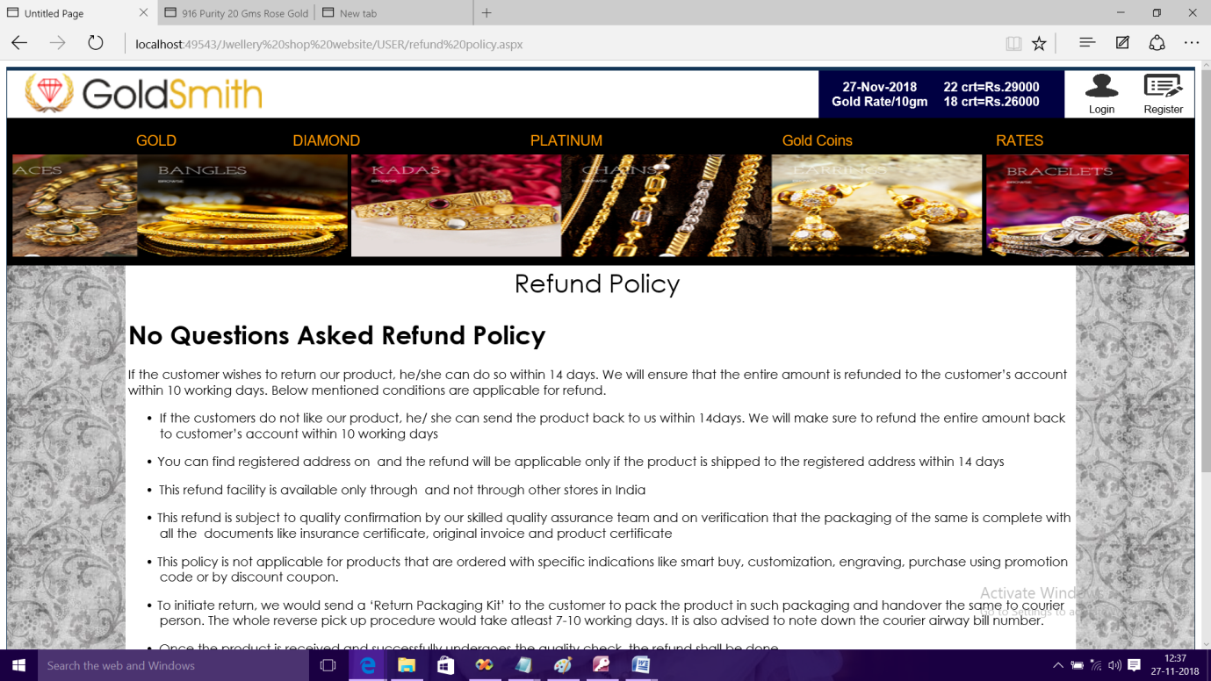

Sizing Guide

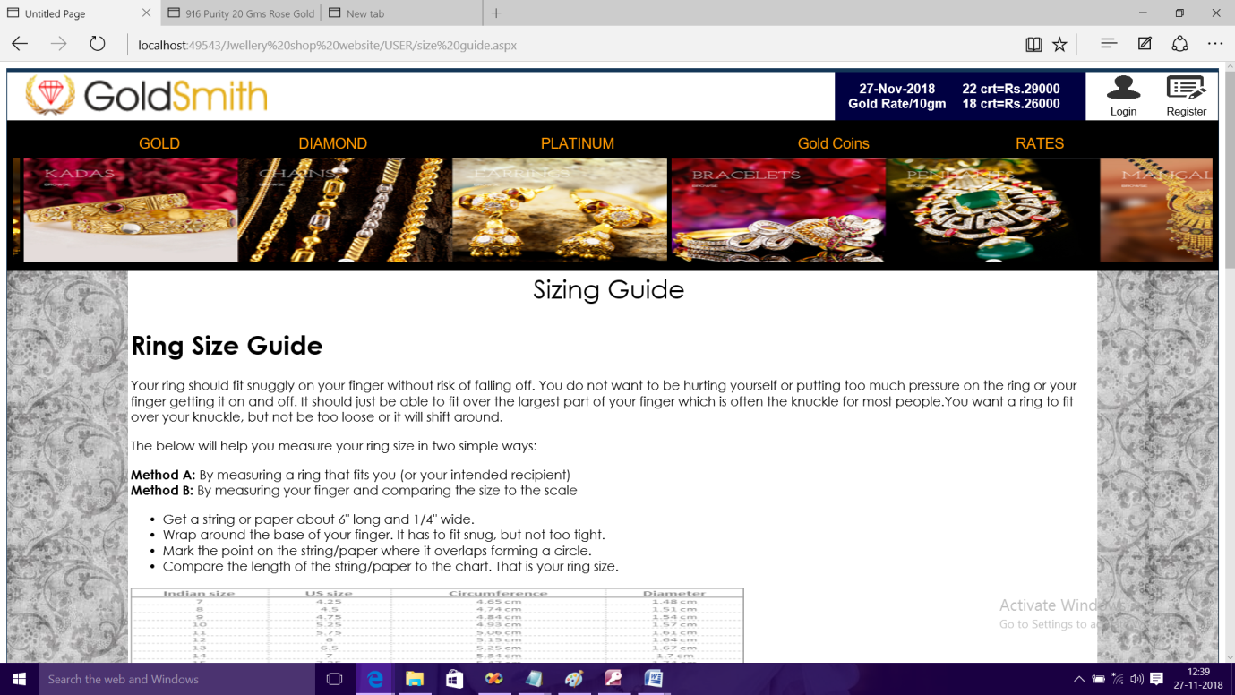

What we do

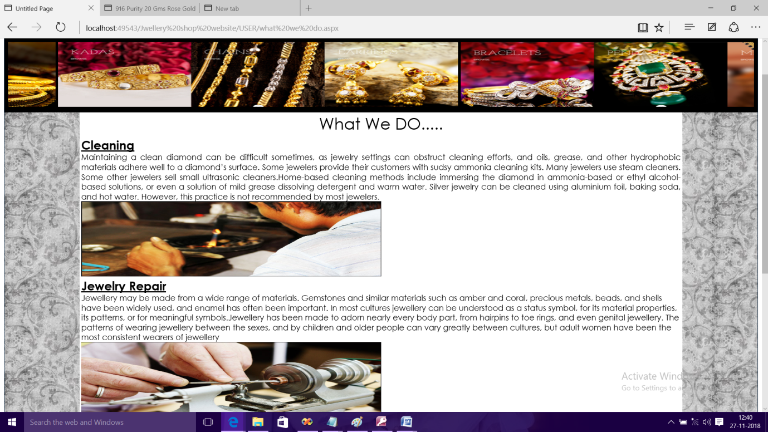

Know your diamond

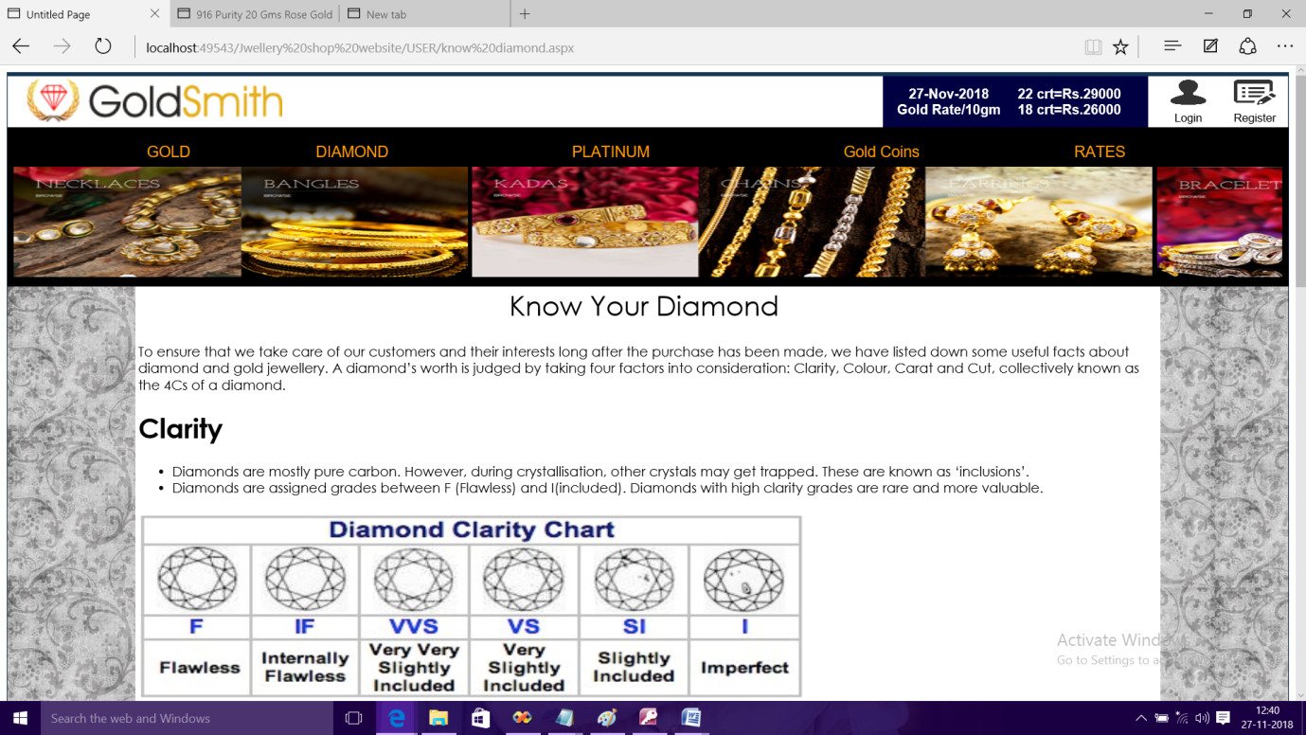

**Feedback:-**

This page shows Feedback form of GoldSmith Jwellery.

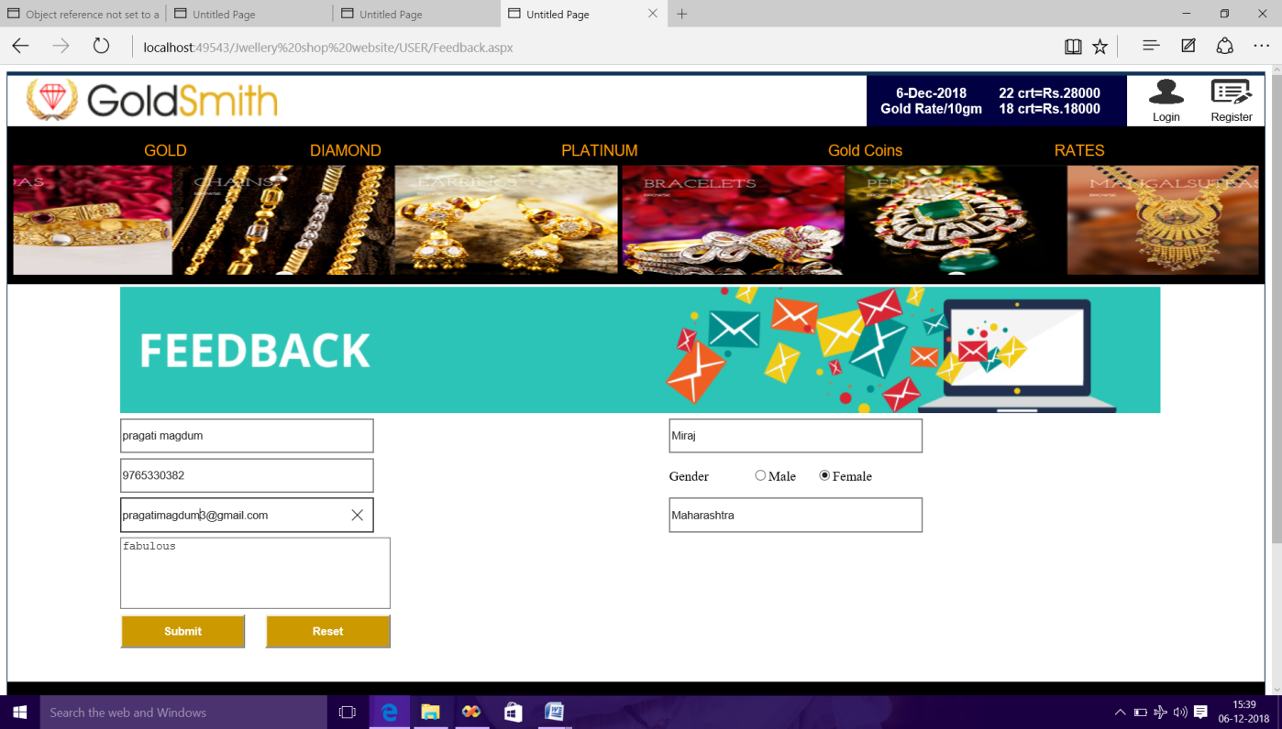

Product Page

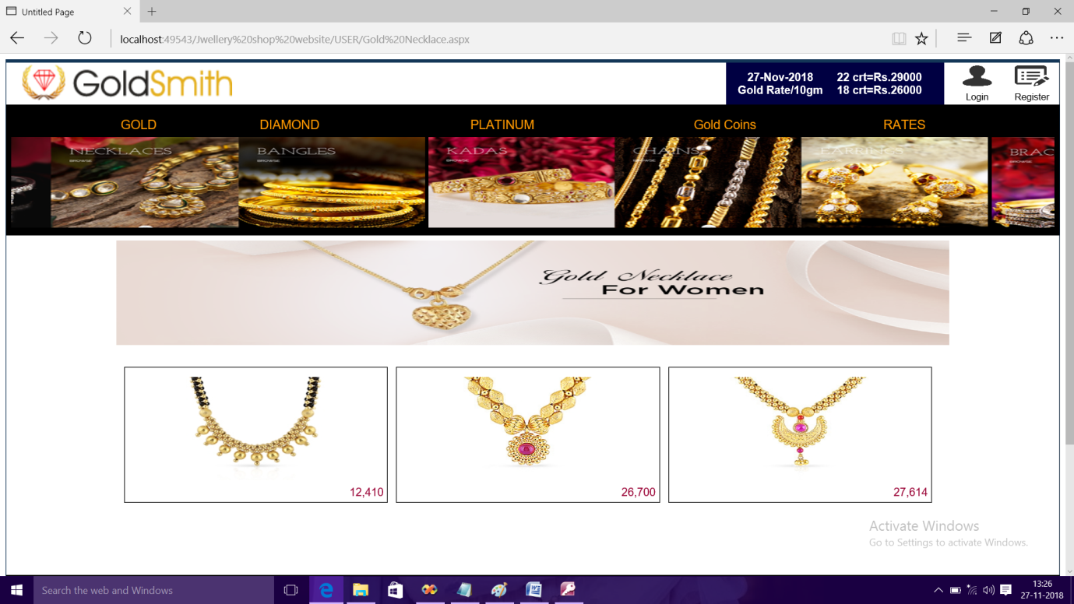

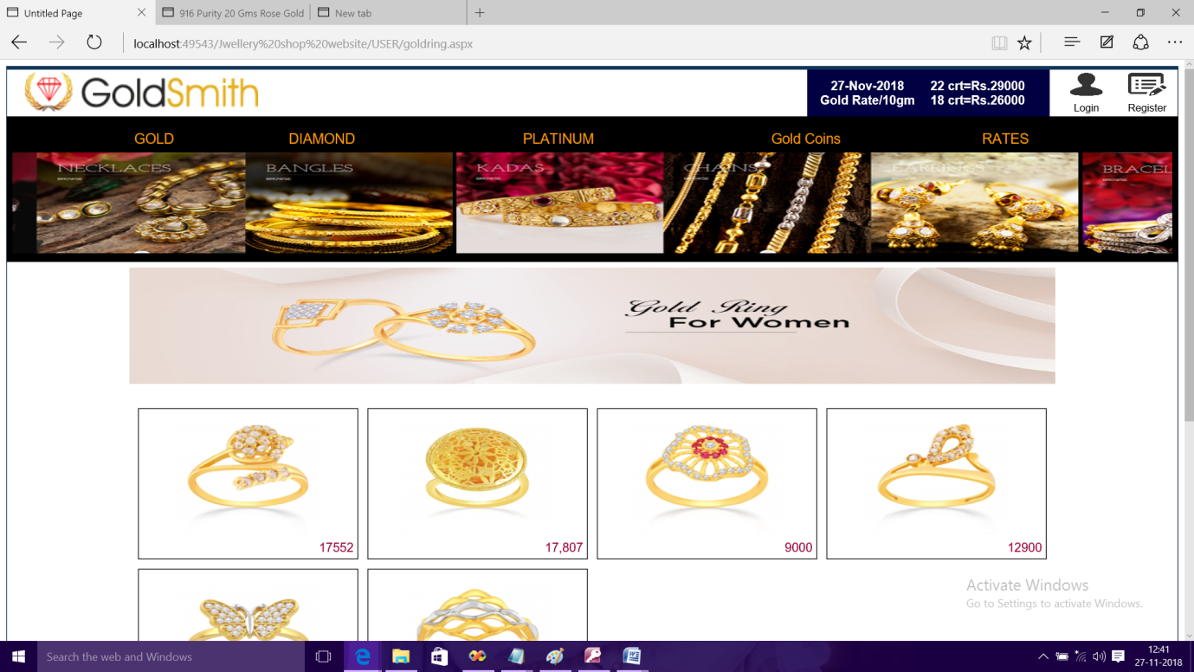

Login Page:-

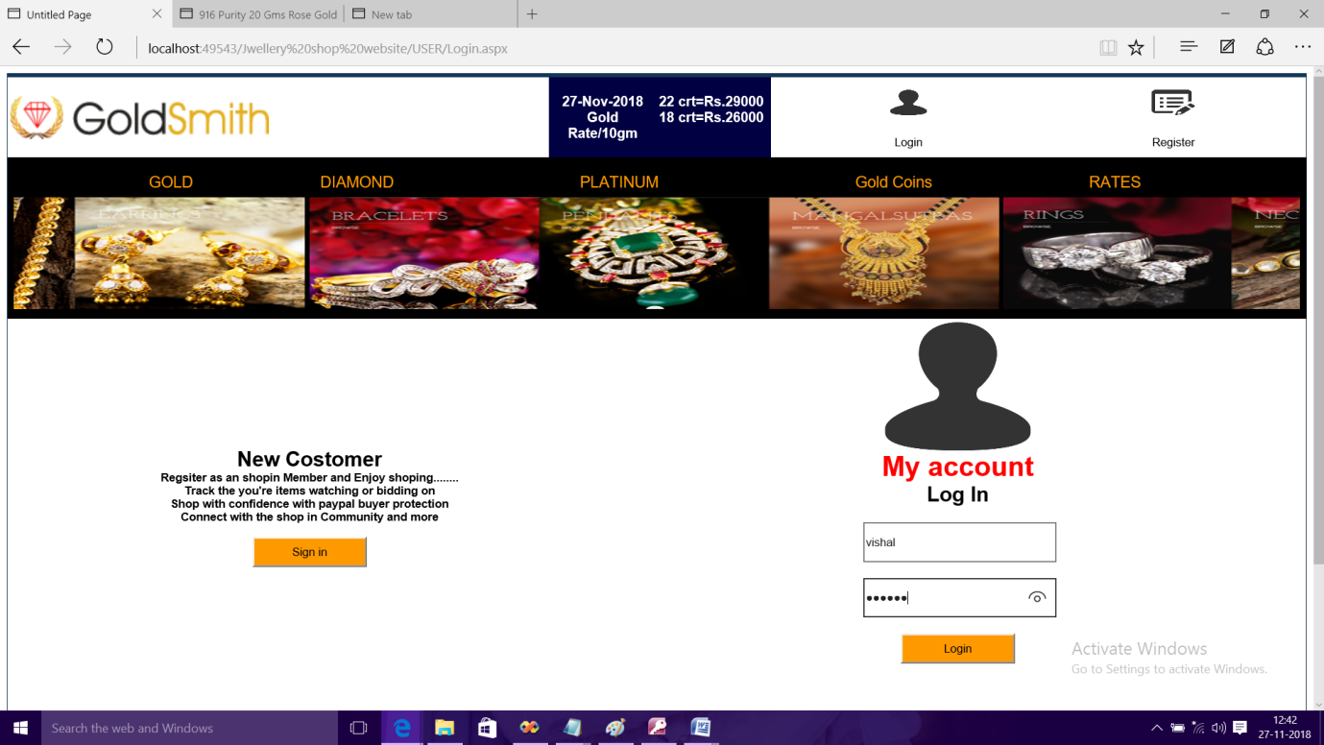

This page shows customer registration form:-

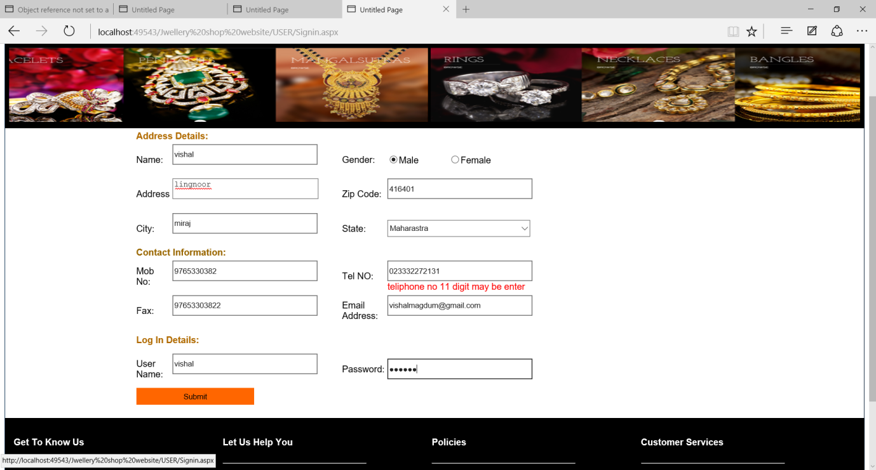

This page shows order detail form:-

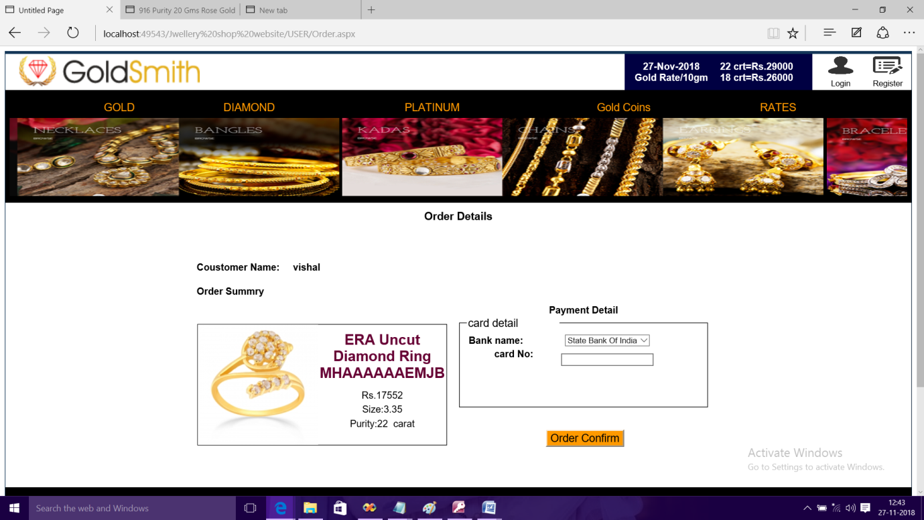

**Admin Panel:-**

**Admin login Page:-**

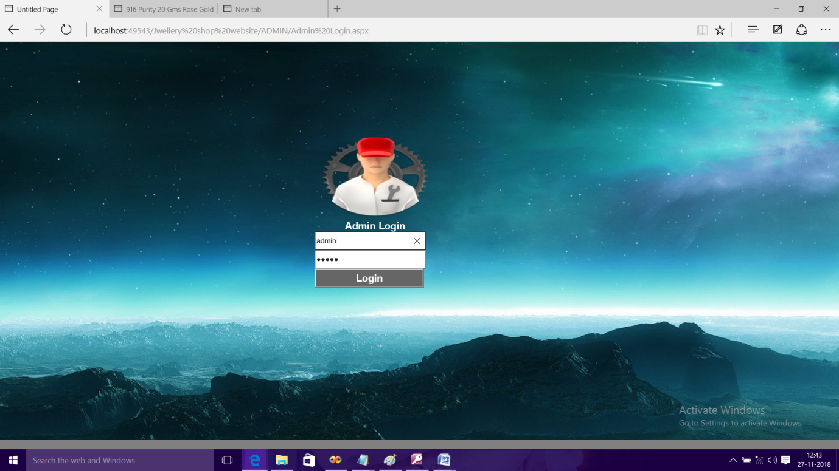

**Admin Home Page:-**

This page is home page of admin.

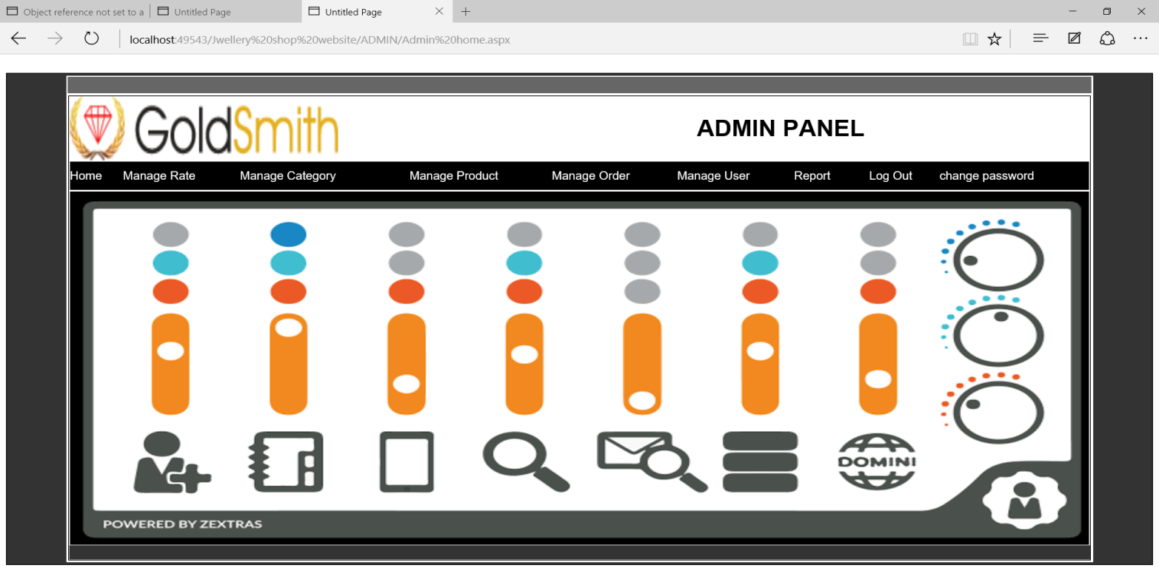

**Add Category:-**

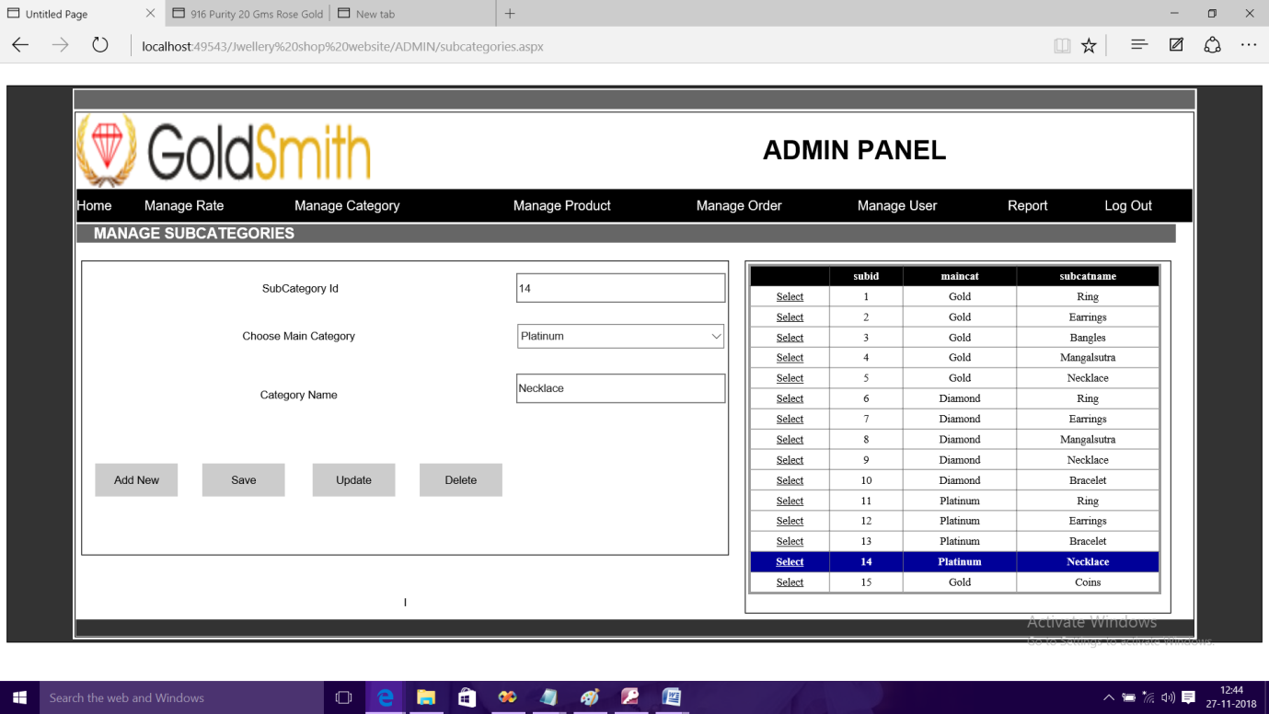

**Add Product:-**

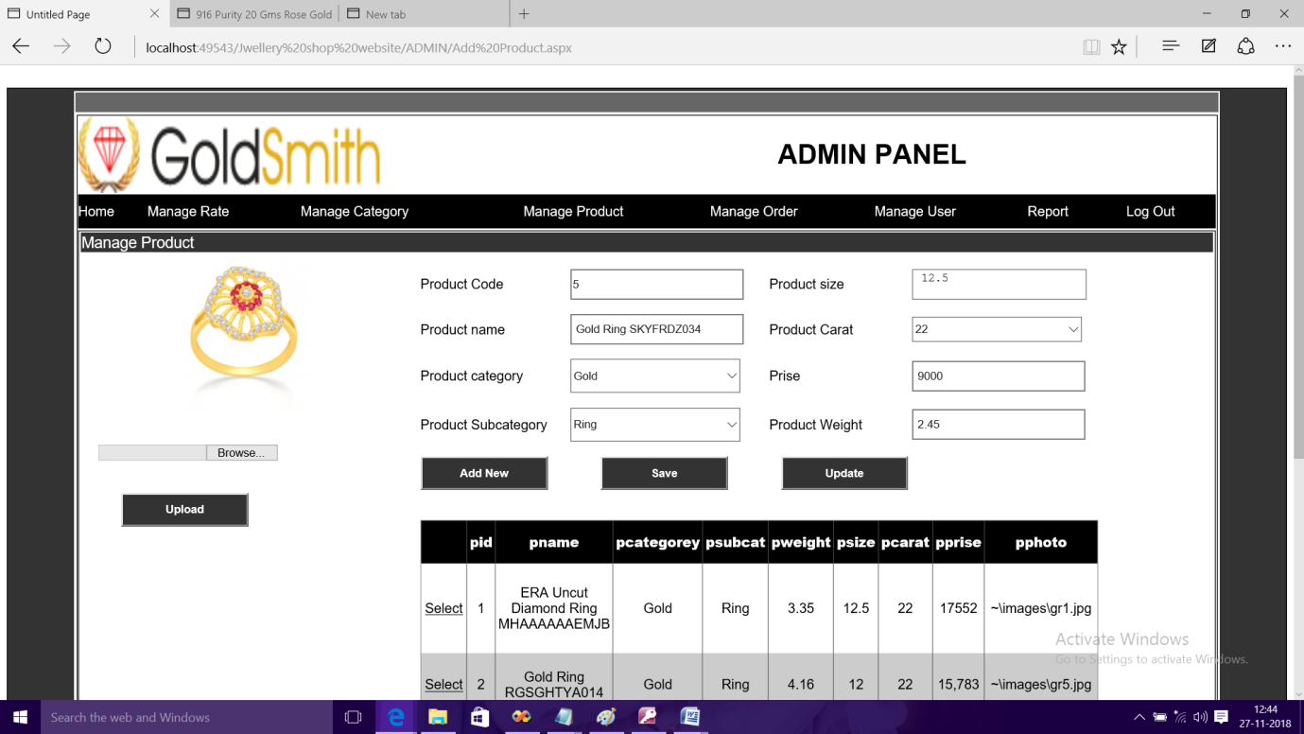

**Manage Order:-**

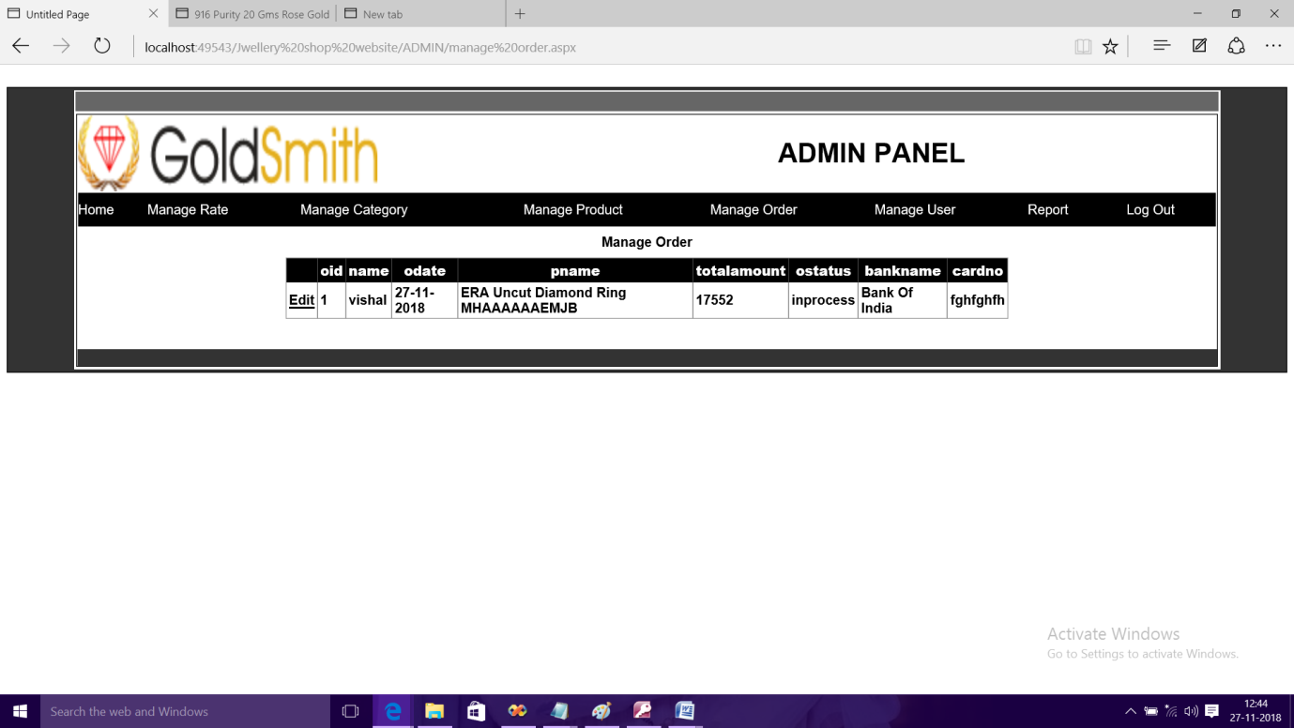

**Manage User:-**

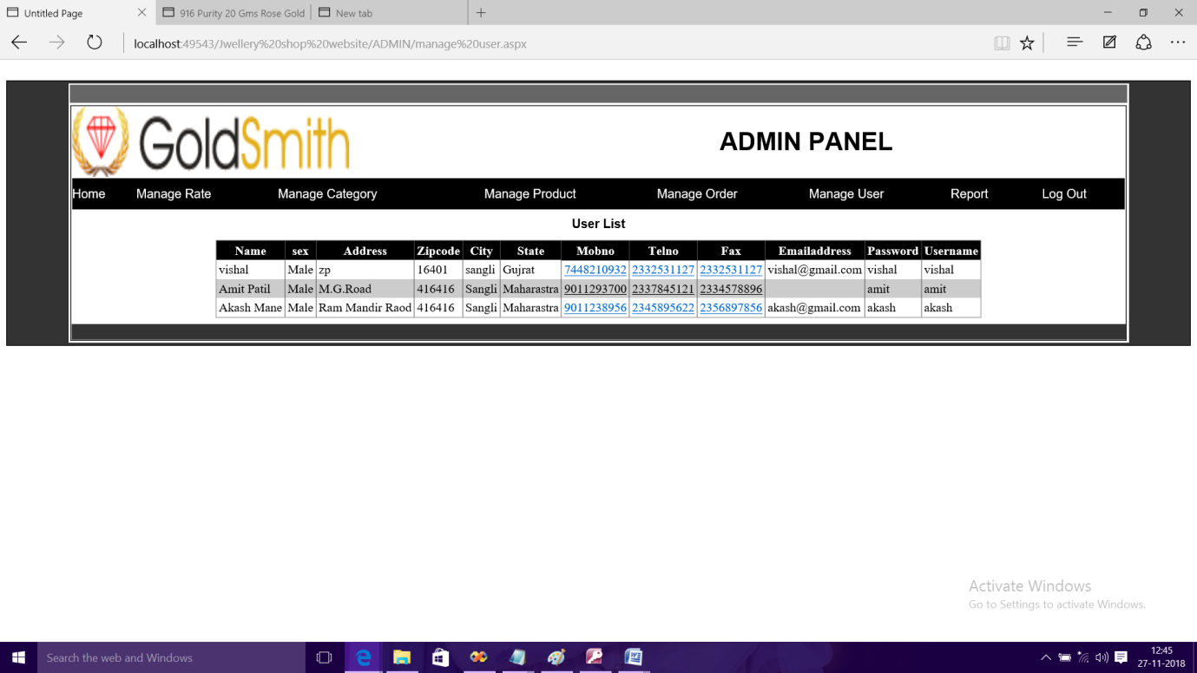

**Reports:-**

Admin Report.

Product Report.

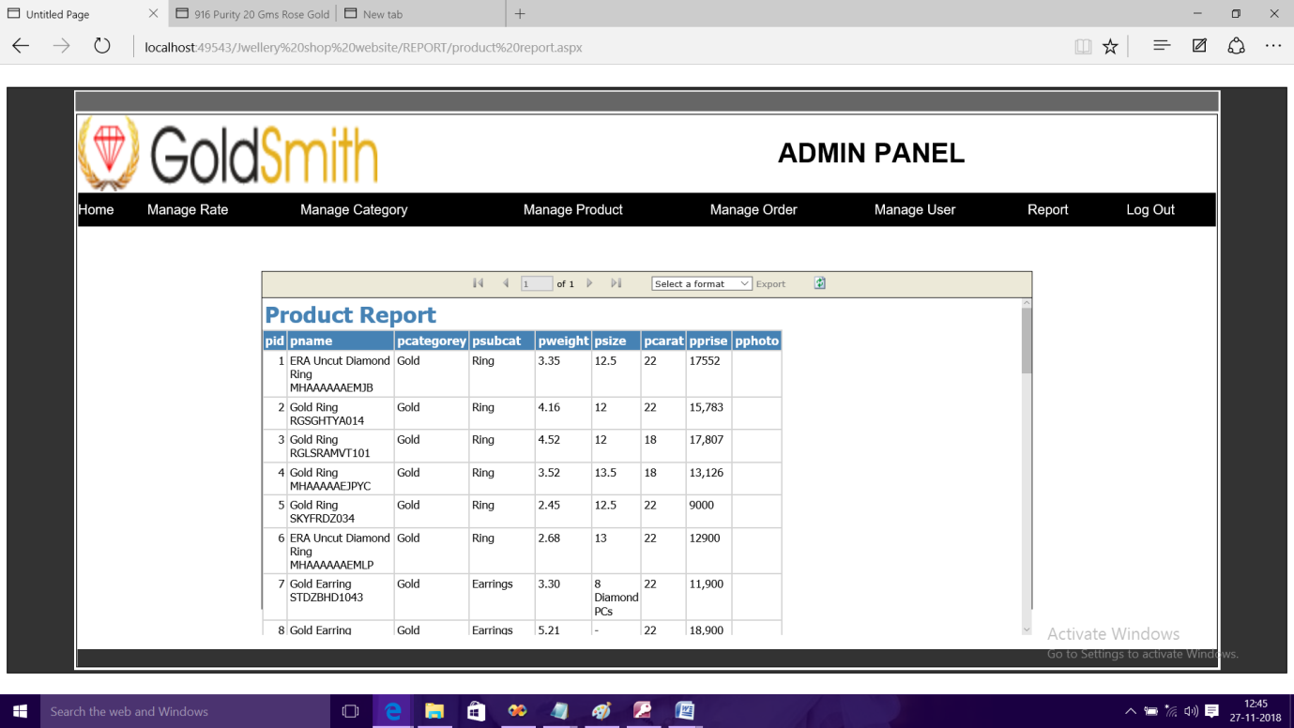

User Report.

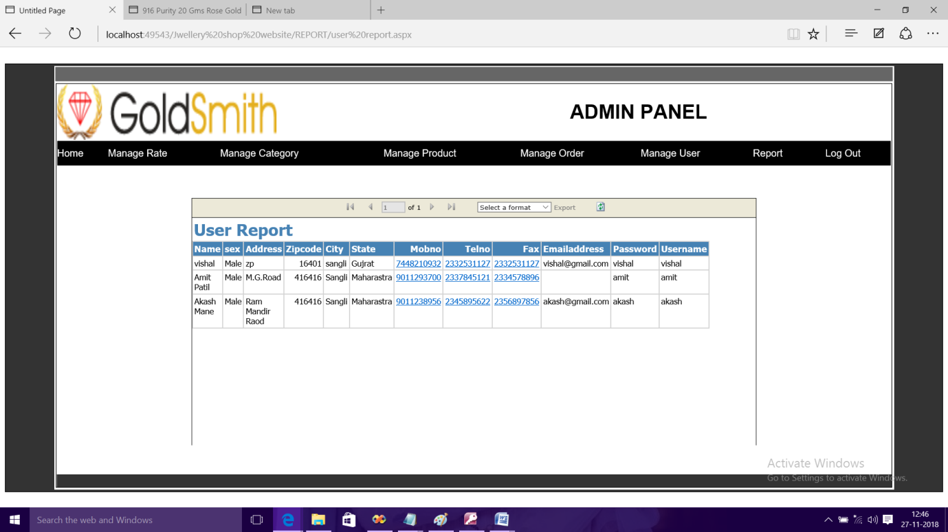

Feedback Report.

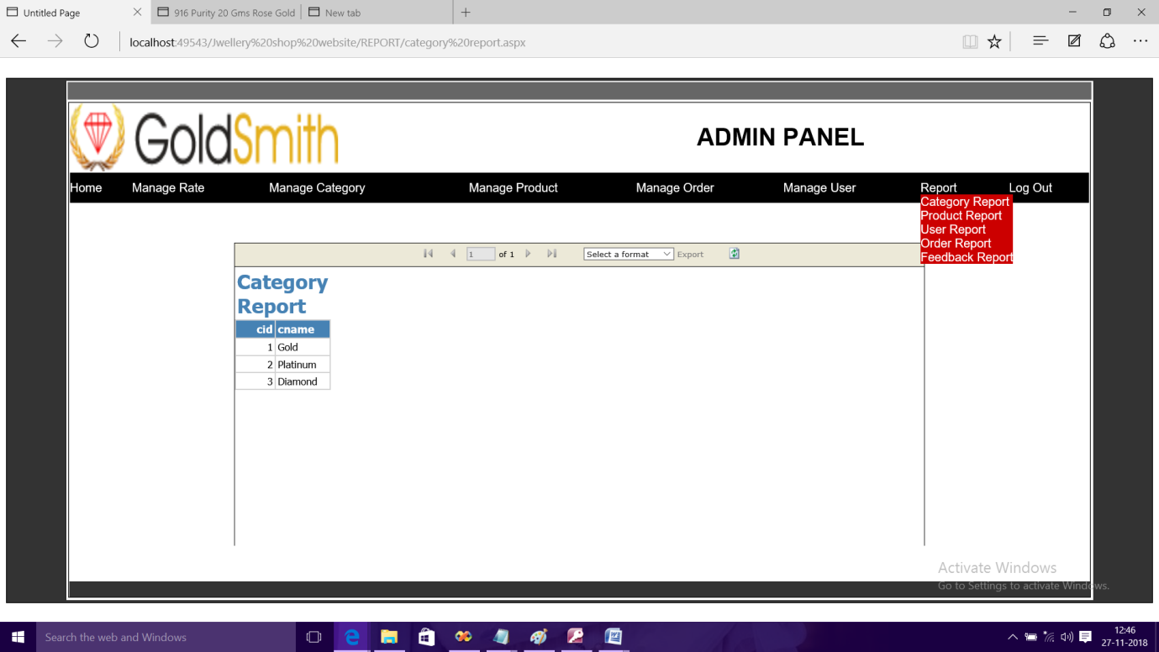

**User Panel:-**

**User Home Page:-**

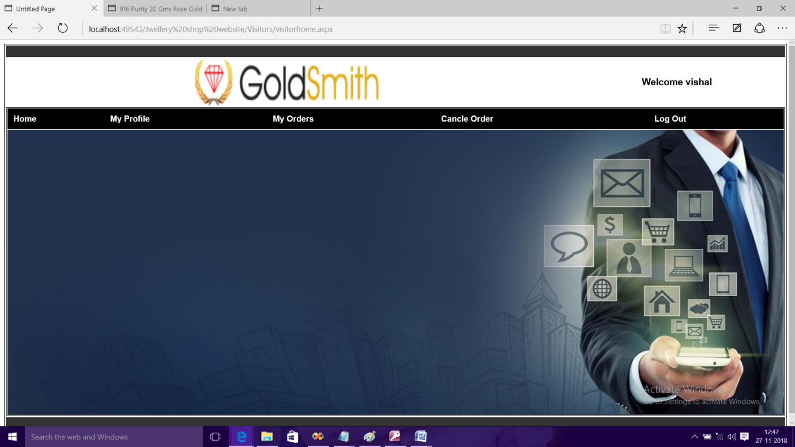

**Profile:-**

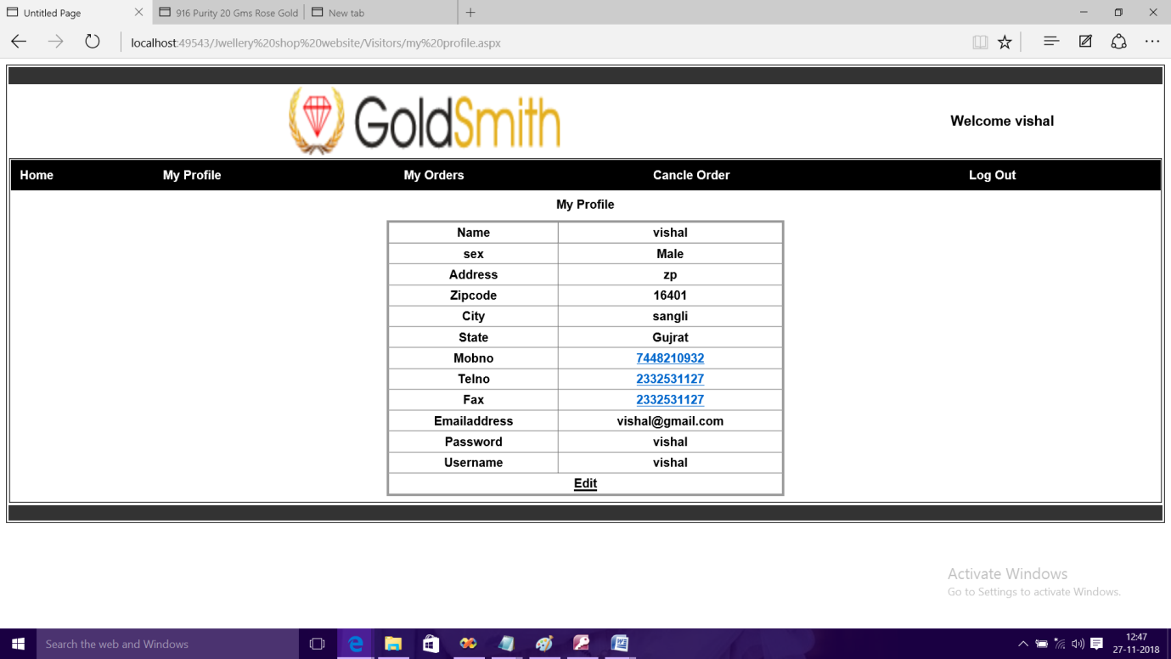

**Order Page:-**

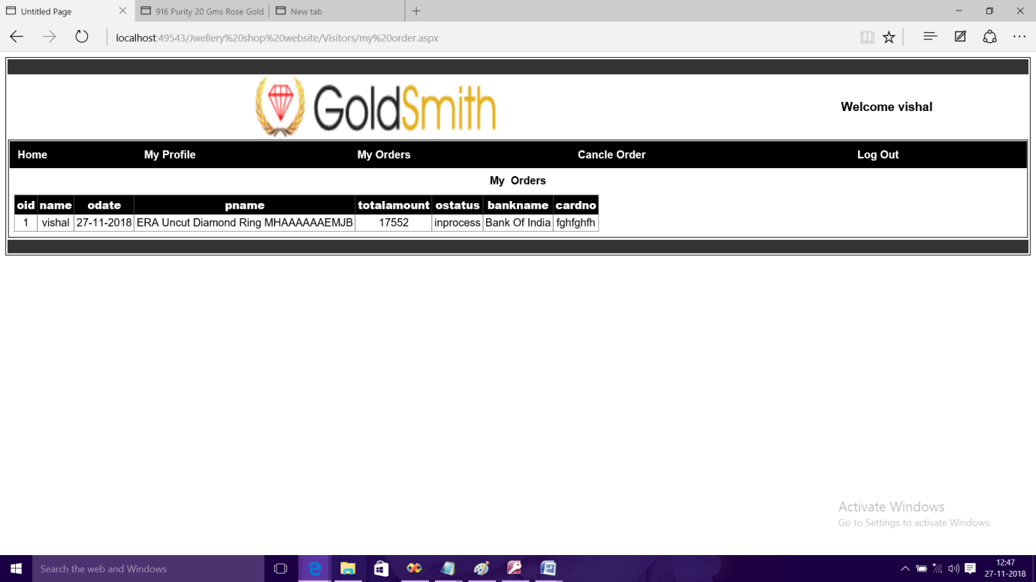

**Deployment Process:-**

* After you have created an ASP.NET Web application project or an ASP.NET Web site project in Visual Studio, you can typically deploy the project to a Web server where others can access your application. Deployment typically involves more than just copying additional tasks, such as following:
* Changing Web.config file setting that must be different in the destination environment, such as setting for debugging or database connection string.
* Propagation data or data structure in database that are used by the Web application.
* Configuration IIS setting on the destination computer, such as the application pool, the authentication method, whether directory browsing is allowed, and error handling.
* Installing security certificates.
* Setting values in the registry of the destination computer.
* Installing application assemblies in the global cache (GAC) on the destination computer.

**Limitations of system:-**

* In this system the customer cannot create a wish list of Jwellery.
* After confirmation of order the bill of individual customer cannot get generated.
* There are some static pages in the website like about us, contact us etc…
* Less report is generated.
* No proper payment gateway is implemented.

**Further Enhancements:-**

* We think that not a single project is ever considered as complete forever because our necessities are growing.
* At first glance you can find it to be complete but we want to make it fully automatic.
* As a system is flexible you can generate more report and screen as and when needed.
* The system is modified in the future as per the requirement.
* We can design the system with secure shopping using various payment gateway services.

We have designed web site “GoldSmith Jwellery” for those who want to buy a Jwellery. This web site is useful for buying the various types of Jwellery which are suitable to various types.

In this website there are various types of Jwellery customer can buy online and able to cancel their orders. Here we are keeping the customer’s information secretly. In this web site the customer gets Registration and Login option for security. We also display our shipping and return product policies.

Through this website admin can view the product in the admin panel. The product can get updated when the new product is added in particular category and also get updated whenever customer buy particular product from category.

To develop this “web application of online purchase of Jwellery” we used

ASP.NET Frontend and MS-Access 2007 backend (database). We take some knowledge

towards automation system from some books that are given below

**Books:-**

1. Black book ASP.NET 2.0
2. MSDN Library

**Web Sites:-**

1. [www.google.com](http://www.google.com)
2. <http://www.msdn.com>
3. [www.pngJweller.in](http://www.pngJweller.in)